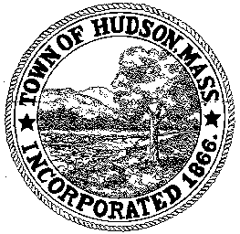

CONSERVATION COMMISSION
78 Main Street, Hudson, MA 01749
(978) 562-2020

Paul Byrne, Chairman W. Minot Wood, Vice Chairman David Esteves, Member

Terrence Joyce, Member Leif Longtine, Member Joseph Rodrigues, Member Al Tashian, Member

Meeting Agenda
February 3, 2011 7:00 P.M.

- Preliminaries
  - Open Meeting
  - Roll Call

2.0 New Business
2.1 Discussion of 11 Otsego Drive

2.2 Request for Review and Comments
258 Washington Street

2.3 Minutes January 20, 2011

2.4 Ratify Enforcement Order for Holiday Inn Express

3.0 Old Business

4.0 Correspondence

5.0 Adjournment:

Next Meeting: February 17, 2011

